Data Communications
AND Networking
Chapter 6
Revision 1



-------------------------------------------------
Easter eggs
Italic lines indicate that text is directly cloned from text book *
Most of the blueish figures are just screenshots taken from text books
Can you find one more? It’s a SECRET, BTW.

Chapter 6 | Quizzes

Describe the goals of multiplexing.
Multiplexing is used for efficiently using our limited bandwidth.

List three main multiplexing techniques mentioned in this chapter.
  - FDM (Frequency division multiplexing)
  - WDM (wavelength division multiplexing)
  - TDM (Time division mulitplexing)

Distinguish between a link and a channel in multiplexing.
Link refers to the physical path and channel refers to the portion of a link that carries a transmission between given pair of lines.

Which of the three multiplexing techniques is (are) used to combine analog signals? Which of the three multiplexing techniques is (are) used to combine digital signals?
Analogue = FDM, WDM
Digital = TDM

Define the analog hierarchy used by telephone companies and list different levels of the hierarchy.
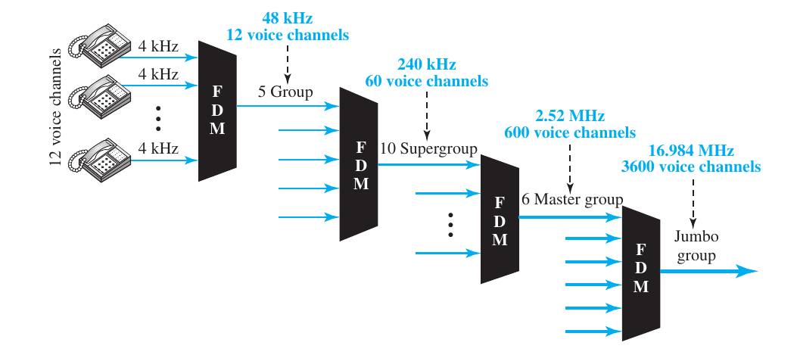
To maximize the efficiency of their infrastructure, telephone companies have traditionally multiplexed signals from lower-bandwidth lines onto higher-bandwidth lines. In this way, many switched or leased lines can be combined into fewer but bigger channels. For analog lines, FDM is used.
In this analog hierarchy, 12 voice channels are multiplexed onto a higher-bandwidthline to create a group. A group has 48 kHz of bandwidth and supports 12 voice channels.
At the next level, up to five groups can be multiplexed to create a composite signal called a supergroup. A supergroup has a bandwidth of 240 kHz and supports up to 60 voice channels. Supergroups can be made up of either five groups or 60 independent voice channels.
At the next level, 10 supergroups are multiplexed to create a master group. A master group must have 2.40 MHz of bandwidth, but the need for guard bands between the supergroups increases the necessary bandwidth to 2.52 MHz. Master groups support up to 600 voice channels.
Finally, six master groups can be combined into a jumbo group. A jumbo group must have 15.12 MHz (6 × 2.52 MHz) but is augmented to 16.984 MHz to allow for guard bands between the master groups.

Define the digital hierarchy used by telephone companies and list different levels of the hierarchy.
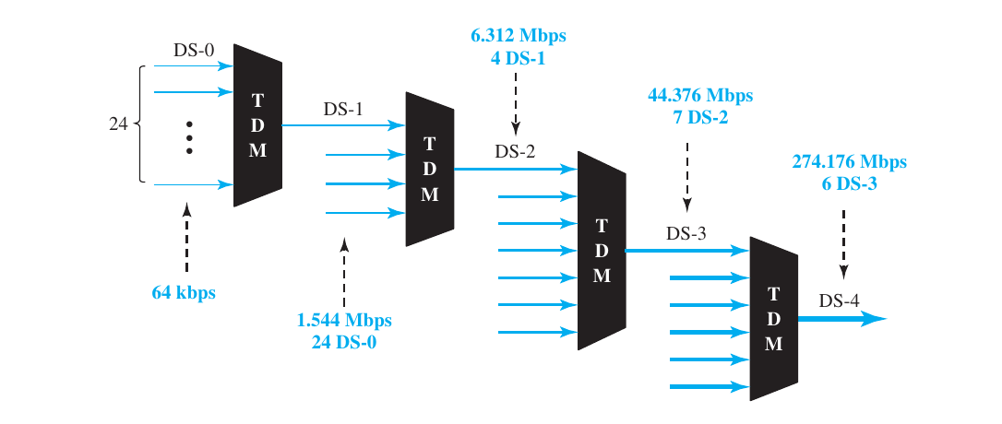
Levels include DS-0,DS-1,DS-2,DS-3 and DS-4.

Which of the three multiplexing techniques is common for fiber-optic links? Explain the reason.
WDM. Because optic has more wavelength.

Distinguish between multilevel TDM, multiple-slot TDM, and pulse-stuffed TDM.
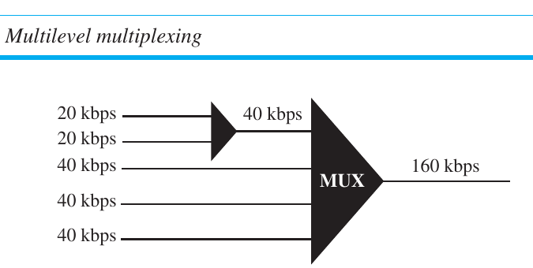
Multilevel multiplexing is a technique used when the data rate of an input line is a multiple of others.
When we allot more than one slot in a frame to a single line.
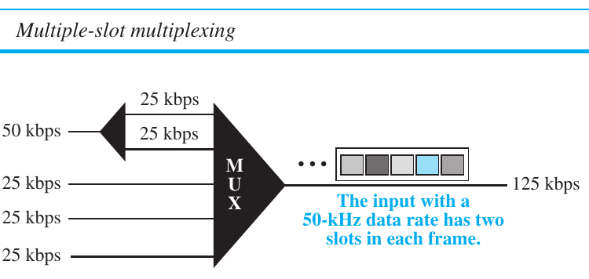
When the bit rates are not multiple integer of each other. Then highest data rate is made into dominant one and dummy bit is added to the lower lines which is known as pulse stuffed TDM.

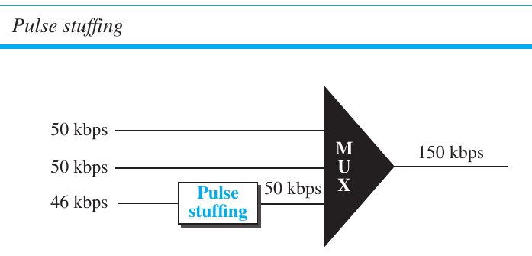
Distinguish between synchronous and statistical TDM.
In synchronous TDM, each input connection has an allotment in the output even if it is not sending data.
And in statistical time-division multiplexing, slots are dynamically allocated to improve bandwidth efficiency.

Define spread spectrum and its goal. List the two spread spectrum techniques discussed in this chapter.
In spread spectrum original signals are combined with different signals to fit into a larger bandwidth. Here the main goal is to prevent problems like eyedropper's interception and jamming.
Two spread spectrum discussed in this chapter are, FHSS (Frequency Hopping Spread Spectrum) and DSSS (Direct Sequence Spread Spectrum).

Define FHSS and explain how it achieves bandwidth spreading.
In FHSS with a psedurandom code generator a bit pattern is generated for almost every bit pattern.

Define DSSS and explain how it achieves bandwidth spreading.
In DSSS, we replace each data bit with n bits using a spreading code.

Chapter 6 | Problems

Assume that a voice channel occupies a bandwidth of 4 kHz. We need to multiplex 10 voice channels with guard bands of 500 Hz using FDM. Calculate the required bandwidth.

We need to transmit 100 digitized voice channels using a passband channel of 20 KHz. What should be the ratio of bits/Hz if we use no guard band?
Refs :: https://stackoverflow.com/questions/16548759/ratio-of-bits-hz-of-digitized-voice-channel

In the analog hierarchy of Figure 6.9, find the overhead (extra bandwidth for guard band or control) in each hierarchy level (group, supergroup, master group, and jumbo group).
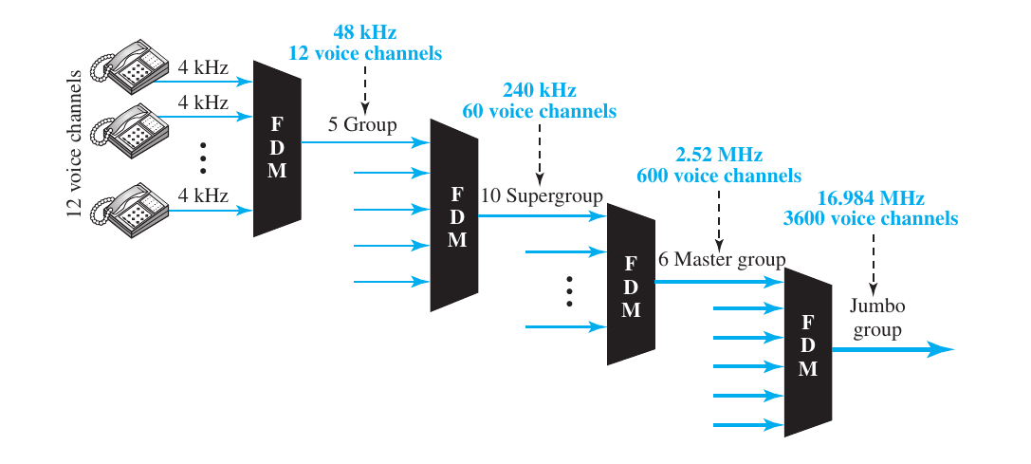
Group = 48 kHz – (4 kHz x 12) = 0 Hz
Super group = 240 kHz – (48 kHz x 5) = 0 Hz
Master group = 2.52 MHz – (240 kHz x 60) = 120 kHz
Jumbo group = 16.984 MHz – (2.52 MHz x 6) = 1.864 MHz

We need to use synchronous TDM and combine 20 digital sources, each of 100 Kbps. Each output slot carries 1 bit from each digital source, but one extra bit is added to each frame for synchronization. Answer the following questions:
a. What is the size of an output frame in bits?
Output frame = 20 x 1 + 1 = 21 bit
b. What is the output frame rate?
Output frame rate = 100,000 frames per second
c. What is the duration of an output frame?
Duration of a frame =
d. What is the output data rate?
Output data rate = 100,000 x 21 = 2100 kbps
e. What is the efficiency of the system (ratio of useful bits to the total bits)?
Efficiency =

Repeat Problem 6-4 if each output slot carries 2 bits from each source.
a. What is the size of an output frame in bits?
Output frame = 20 x 2 + 1 = 41 bit
b. What is the output frame rate?
Output frame rate = 50,000 frames per second
(two bit is taken so we may need extra 2x time, check example 6.9 from text book)
c. What is the duration of an output frame?
Duration of a frame =
d. What is the output data rate?
Output data rate = 50,000 x 41 = 2050 kbps
e. What is the efficiency of the system (ratio of useful bits to the total bits)?
Efficiency =

We have 14 sources, each creating 500 8-bit characters per second. Since only some of these sources are active at any moment, we use statistical TDM to combine these sources using character interleaving. Each frame carries 6 slots at a time, but we need to add 4-bit addresses to each slot. Answer the following questions:
a. What is the size of an output frame in bits?
Frame size = 6 x ( 8 + 4 ) = 72 bits
b. What is the output frame rate?
Output frame rate = 500 frames per second
c. What is the duration of an output frame?
Duration of output frame = 1 / 500 = 0.002 second or, 2 ms
d. What is the output data rate?
Output data rate = 500 x 72 = 36000 bps or 36 kbps
--
I hope output frame and data rate should be easy for you to figure out once you know the number of bits per frame and frame rate! So I’ll be skipping these two.

Ten sources, six with a bit rate of 200 kbps and four with a bit rate of 400 kbps, are to be combined using multilevel TDM with no synchronizing bits. Answer the following questions about the final stage of the multiplexing:

a. What is the size of a frame in bits?
If we mulitplex 6 sources of 200 kbps into 3 400 kbps, we will need total 7 (4+3) bits in a frame.
b. What is the frame rate?
Frame rate = 400 frame per second
c. What is the duration of a frame?
Frame duration = 1 / 400,000 = 2.5 µs
d. What is the data rate?
Data rate = 400 x 7 = 2.8 Mbps

Four channels, two with a bit rate of 200 kbps and two with a bit rate of 150 kbps, are to be multiplexed using multiple-slot TDM with no synchronization bits. Answer the following questions:
a. What is the size of a frame in bits?
Here we can divide 200 kbps lines into 4 = 50 kbps lines, and 150 kbps lines into 3 = 50 kbps lines. So we will have total of 7 lines. In this way we will have 7 bits per frame.
b. What is the frame rate?
Frame rate = 50,000 frames per second
c. What is the duration of a frame?
Duration = 1 / frame rate = … (try yourself...)
d. What is the data rate?
Data rate = frame rate x 7 bits = …
I am not sure, feel free to reach me out.

Two channels, one with a bit rate of 190 kbps and another with a bit rate of 180 kbps, are to be multiplexed using pulse-stuffing TDM with no synchronization bits. Answer the following questions:
a. What is the size of a frame in bits?
Size = 2
b. What is the frame rate?
Frame rate = 180,000 frames per second (not sure)
c. What is the duration of a frame? (do yourself)
d. What is the data rate? (do yourself)

Answer the following questions about a T-1 line:
a. What is the duration of a frame?
Duration = 1 / 8000 sec
b. What is the overhead (number of extra bits per second)?
The number of extra bits per second will be 8000 x 1 = 8000 bps.

Show the contents of the five output frames for a synchronous TDM multiplexer that combines four sources sending the following characters. Note that the characters are sent in the same order that they are typed. The third source is silent.
a. Source 1 message: HELLO
b. Source 2 message: HI
c. Source 3 message:
d. Source 4 message: BYE

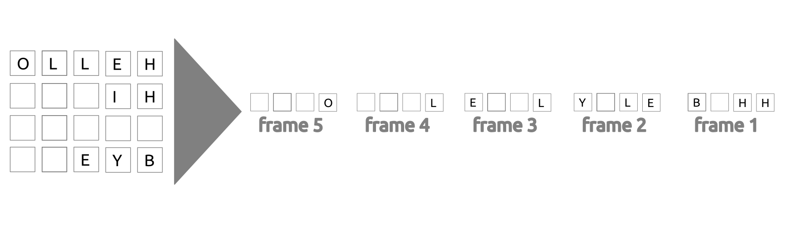
Figure 6.34 shows a multiplexer in a synchronous TDM system. Each output slot is only 10 bits long (3 bits taken from each input plus 1 framing bit). What is the output stream? The bits arrive at the multiplexer as shown by the arrows.
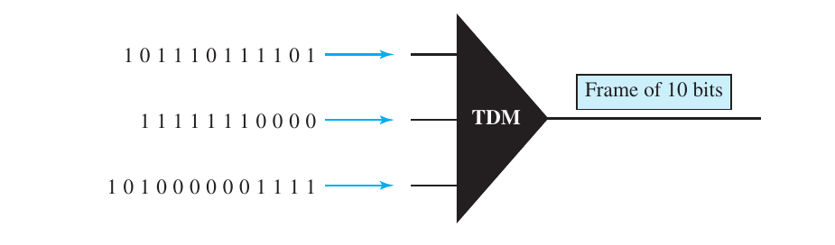
First slot = 1 111 000 101
Second slot = 0 001 110 111
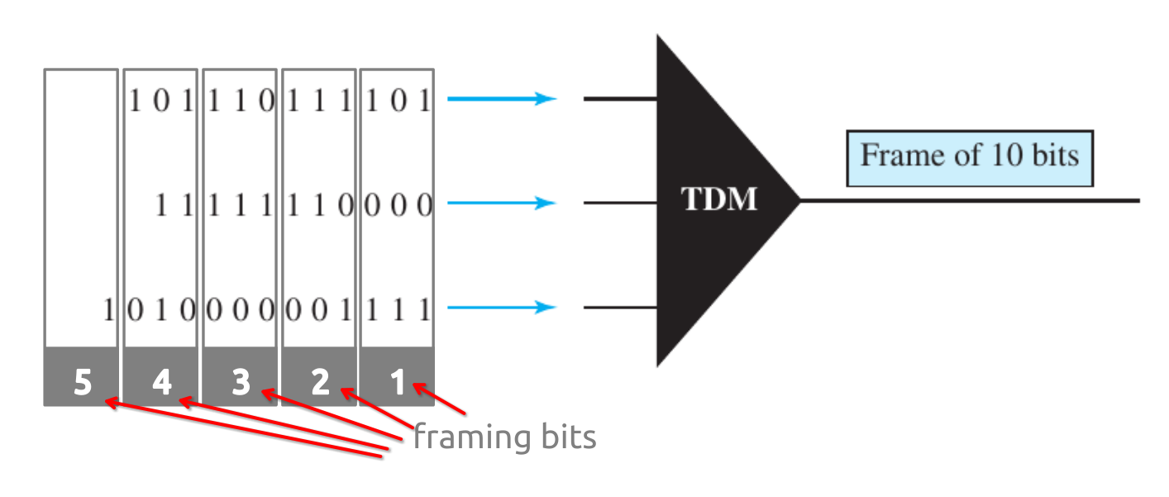
… so on,
(try yourself)

Figure 6.35 shows a demultiplexer in a synchronous TDM. If the input slot is 16 bits long (no framing bits), what is the bit stream in each output? The bits arrive at the demultiplexer as shown by the arrows.
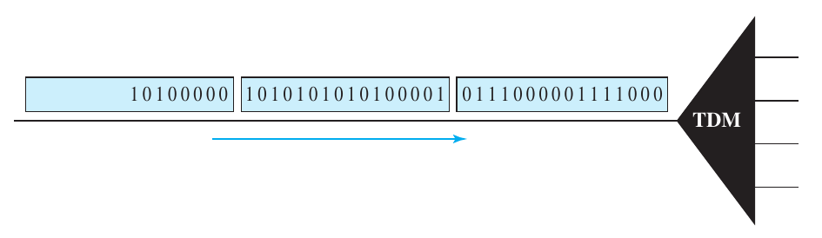
Output line 1 = 1000 0001 0000
Output line 2 = 0111 1010 1010
Output line 3 = 0000 1010
Output line 4 = 0111 1010
refs :: https://static.aminer.org/pdf/PDF/000/274/977/simultaneous_transmission_of_data_fdm_signals.pdf
Also check sadman’s solution, that’s more descriptive!

Answer the following questions about the digital hierarchy in Figure 6.23:
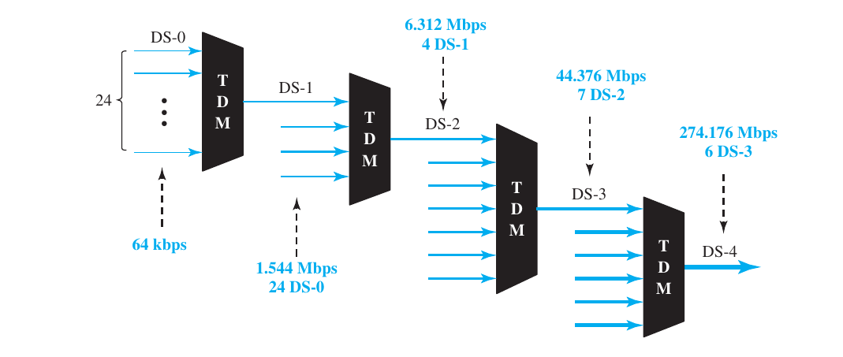
a. What is the overhead (number of extra bits) in the DS-1 service?
DS-1 overhead = 1.544 Mbps – ( 64 kbps x 24 ) = 8000 bps or 8 kbps
b. What is the overhead (number of extra bits) in the DS-2 service?
DS-2 overhead = 6.312 Mbps - ( 1.544 Mbps x 4 ) = 168 kbps (not accurate)
DS-2 overhead = 6.312 Mbps - ( 64 kbps x 24 x 4 ) = 168 kbps
c. What is the overhead (number of extra bits) in the DS-3 service? (try yourself)
d. What is the overhead (number of extra bits) in the DS-4 service? (try yourself)
Results will be 1.368 Mbps (672 times 64 kbps) and 16.128 Mbps (check book, page 171)

What is the minimum number of bits in a PN sequence if we use FHSS with a channel bandwidth of B = 4 KHz and Bss = 100 Khz?

An FHSS system uses a 4-bit PN sequence. If the bit rate of the PN is 64 bits
per second, answer the following questions:
a. What is the total number of possible channels?
b. What is the time needed to finish a complete cycle of PN?

